# Breathing lamp

**In the first lesson, we learn to control the LED, which is the simplest output module.We can control LED light through digital output and analog output. There are just two states of digital output:“on” and “off”, and analog output can control the brightness of LED lights.**

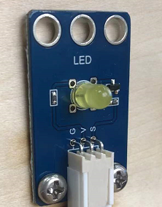

**Principle of LED：**LED light is composed of light emitting diode and protective shell, which can convert electric energy into light energy.

The sample program of the course is in the folder shown below.

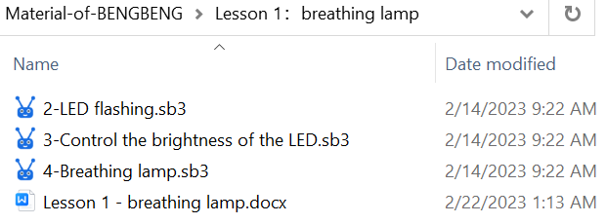

## Install the breathing lamp

|  |  |
| --- | --- |
| 呼吸灯_空白视图 2 | 呼吸灯_空白视图 2_1 |
| 呼吸灯_空白视图 2_2 | 呼吸灯_空白视图 2_3 |
| 呼吸灯_空白视图 2_4 | 呼吸灯_空白视图 2_5 |
| 呼吸灯_空白视图 2_6 | 呼吸灯_空白视图 2_7 |
| 呼吸灯_空白视图 2_8 | 呼吸灯_空白视图 2_9 |
| 呼吸灯_空白视图 2_10 | 呼吸灯_空白视图 2_11 |
| 呼吸灯_空白视图 2_12 | 呼吸灯_空白视图 2_13 |
| 呼吸灯_空白视图 2_14 | 呼吸灯_空白视图 2_15 |
| 呼吸灯_空白视图 2_16 | 呼吸灯_空白视图 2_17 |
| Connect the LED to D11 pin on the expansion board as shown in the right figure. |  |

## LED flashing

Use the digital output program block to control the LED light on and off, flashing like a firefly.



1. **Program block**

|  |  |
| --- | --- |
|  | This is a required starting block. |
|  | The repeated execution block is to make the program in it be executed repeatedly. |
|  | Set pin mode: Define the pin mode of the electronic module according to whether it is input or output. Generally, LED light, buzzer, motor and steering gear are output modes, while sensors are input modes, such as buttons, tracking sensors, obstacle avoidance sensors, photosensitive sensors, etc. |
|  | Set the level (voltage) of pin output to be high or low. Generally, the high level voltage is 5V and the low level voltage is 0V. |
|  | The waiting time block (delay block) enables the program to stay in this block for the set time. |

The blocks can be found in the code area on the left according to its color.

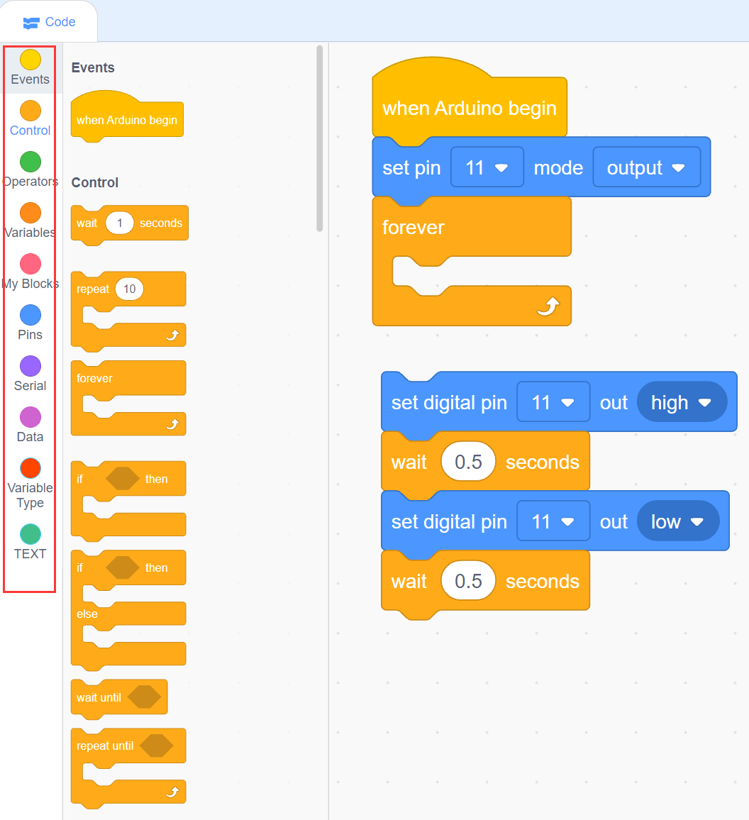

1. **Example code:**

**The code to control the LED to flash**

|  |
| --- |
|  |

**（2）Experiment operation and phenomenon**

Connect the USB data cable, connect the software to the main board, and then click “Upload”.

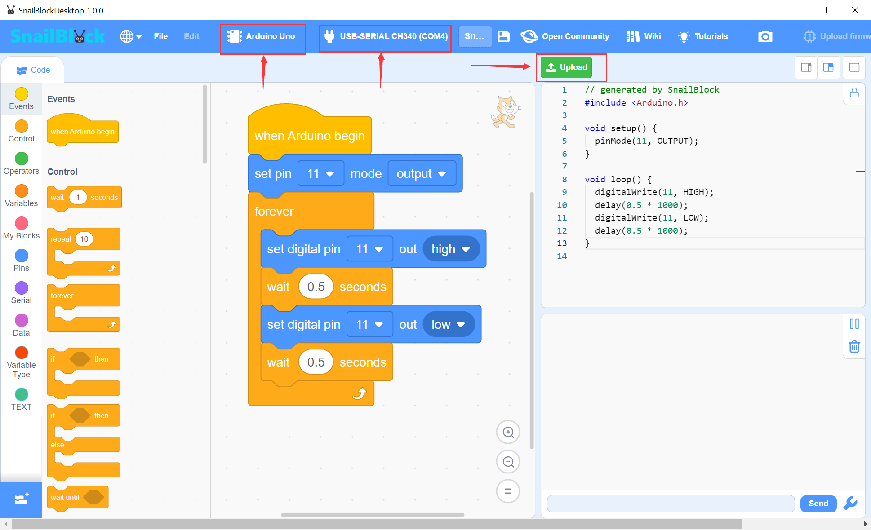

After the upload is successful, you can see that the LED is flashing at an interval of 0.5 seconds.

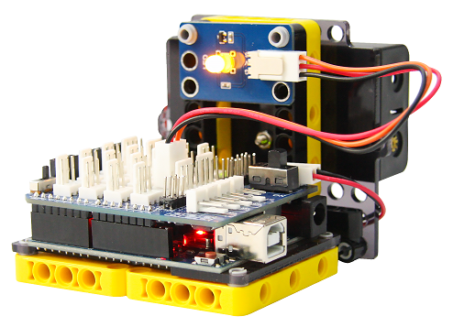

***Tips:*** *It is recommended to modify the value of the waiting time block and observe whether the flashing frequency of the LED has changed. Remember to burn the code again after modification.*

## Control the brightness of the LED

Use PWM output program block to control LED to emit light of different brightness.

The principle of PWM output control LED brightness is that the proportion of high level in a certain period of time, the higher the proportion, the greater the brightness, as shown in the following figure. The maximum output voltage of the IO port of our main board is 5V, so the voltage corresponding to the high level ratio is 0%-100% = 0-5V.

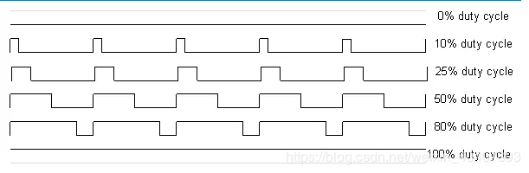

1. Program block

|  |  |
| --- | --- |
| **PWM output pin** | **The PWM output pins of the Arduino UNO main board are 3,5,6,9,10 and 11.** |
|  | The value range of PWM output program block is 0-255. |

1. Example code

|  |
| --- |
|  |

1. Experiment phenomenon

After uploading successfully, you can see that the LED emits 4 different brightness lights.

*Tips：Modify the value of PWM output by yourself, then upload it and watch the LED brightness change.*

## Breathing lamp

Write a program to control the LED to turn on and then turn off gradually, just like breathing.

1. **Program block**

|  |  |
| --- | --- |
| Variable program block:  The simple understanding of variables is the amount that can be modified, for example, the initial assignment is 0, and it can be modified to 5 or other values in the subsequent program.    Declare a local integer variable with the name of i and the value of 0.    Set the variable value which can be modified by this program block.    Take the value of the variable | |
|  | The program block placed inside will repeat the set number of times, here is 255 times. |
|  | Addition and subtraction operation |

1. **Example code**

|  |
| --- |
|  |

1. **Program explanation**

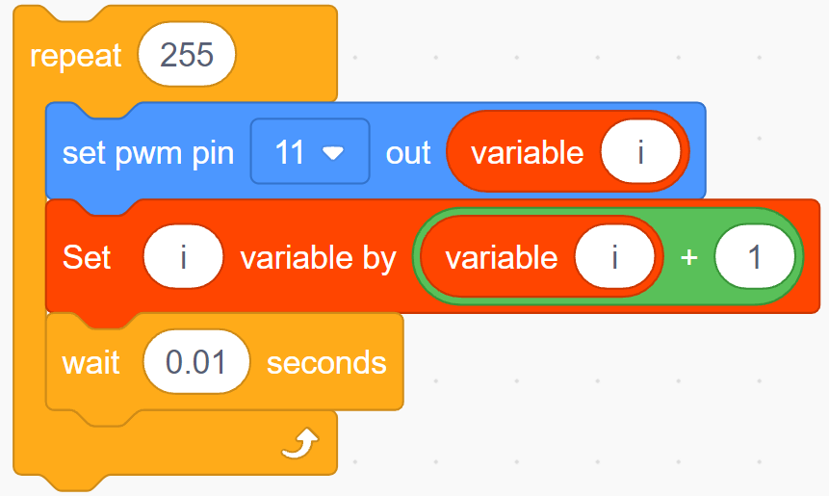

Repeat for 255 times, and the variable i = i + 1 (0+1 , 1+1 , 2+1 , 3+1 ... 254+1). You can see that the value of i gradually increases from 0 to 255. Then set the value of PWM to i, so that the brightness of the LED will gradually increase.

1. **Experiment phenomenon**

After uploading the program, the LED gradually turns on and then turns off, and it keeps cycling, as if the light is breathing.